Instructions for Preparation of Abstracts for IAMUC at AGA21

Author 1ª, Author 2^{b}, Author 3ª, …

ª IAMU Member Institution 1, City, Postal code, Country
^{b} Institution 2, City, Postal code, Country
e-mail: xxx@xxx.xx.xx

Keywords: (3-5 words)
Abstract text. Please use Times Roman as your font, 11-point font size. The title should be presented in 13-point or larger. The title and author list should be presented centrally, while the paragraphs of the abstract should be justified. The presenting author's name should be underlined in the author list. A contact e-mail address of the corresponding author only should be provided. References should be cited in the text and appeared on the bottom of the first page [1]. References can be in any style or format as long as the style is consistent.
Abstracts are limited to one page of text and a second, optional page with up to four figures/tables. The abstract should explain clearly the content and relevance of the paper. Authors are recommended to use DOCX or PDF as the file format. Authors should submit their abstracts electronically to iamuaga21@bsma.edu.ge. The abstract submission deadline is 15th of February 2020.
The theme of the IAMUC is Best Practice: MET and Research for Sustainable Development. When submitting your abstract, please indicate one of the following theme categories in which the abstract will be registered and reviewed:
- Environmental aspect,
- Technological aspect,
- Economic aspect,
- Social aspect,
- Policy aspect.
Submission of an abstract will be taken to imply that it represents an original work and that it has not been previously published or considered elsewhere for publication. Please be aware that authors are responsible for the English language quality of the text. Notification of acceptance will be given to the corresponding author by 15th of March 2020.
The accepted abstract will be assigned by the International Program Committee for oral or poster presentation, not only on the basis of the author's preference indicated in the email submission, but also on the quality of the abstract and number of the oral presentations allocated.
All presented abstracts will be published in the Conference Book with assigned ISSN identifier. The authors will be invited to submit a full paper version for inclusion in the IAMUC Proceedings. Instruction to prepare the full paper will be emailed together with the notification of the abstract. The full paper will be requested by 15th May 2020. The Proceedings papers authors will have opportunity to submit an extended version of the paper to the IAMU Section of the WMU Journal of Maritime Affairs.

References:
[1] Author1, Author2, Article title/chapter title, Journal title/book title, Year of publication, Volume number/book chapter, Page number.

Table 1. Insert concise explanation of the table here.
ECDIS | Manufacture | Japan Radio Co. Ltd.
 | Model | JAN-901B
 | Serial No. | KG 01130
 | IMO compliant | Yes
General | Operating system | Windows XP embedded
 | Power supply | AC 100-115, 200-230 V ±10%,  60/50Hz ±5%
Chart management | Updating | Semi-auto / manual
 | Data correction | Available
Interfaces | Gyro input | IEC61162-2
 | Log input | IEC61162-1
 | Remote maintenance | Possible
 | Copying route | FD / USB
 | Network | LAN (10/100 Mbps)
Hardware design | Vibration absorber | Yes
 | CD/DVD ROM drive | Yes
 | Dual hard disk | Yes
 | Battery for auto shut down | Yes
 | Serial interface | Gyro, Doppler log, GPS, NAVTEX,  Echo sounder, ARPA, AIS and Auto pilot

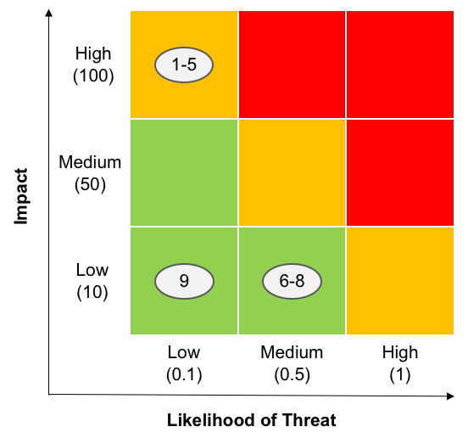 | 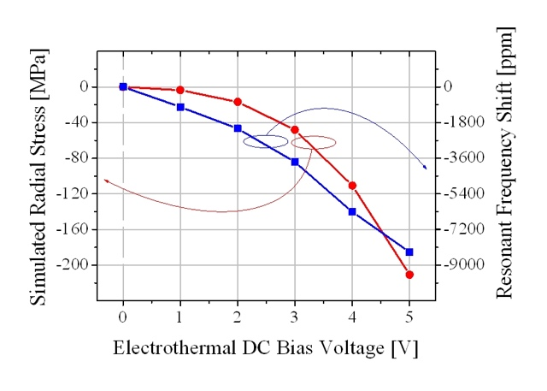
Figure 1. Insert concise explanation of the figure here. | Figure 2. Make sure that in plots and graphics the line width, text fonts, markers and legends are of adequate size to make them fully readable, and that the resolution of the figures is sufficient.

Acknowledgements
If a funding has been provided for the research, please include brief information on the program or type of grants and awards.

